**Computing History**

**Level 0 :**

Motherboard

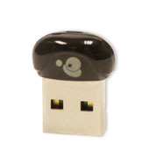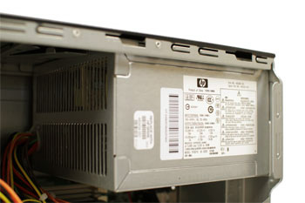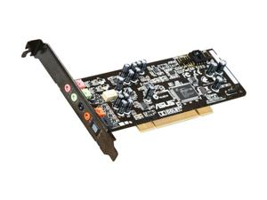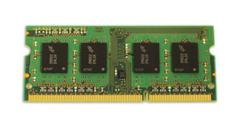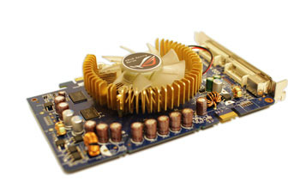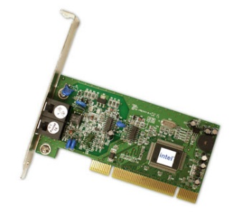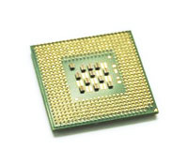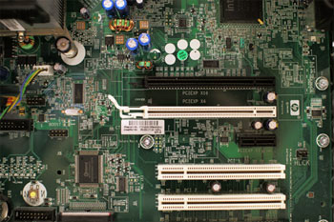

Bluetooth Card or Adapter

Power Supply Unit

Sound Card

Random Access Memory

Video Card

Network Card

CPU/processor

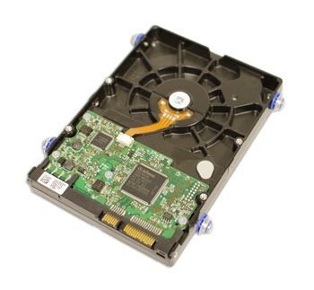

Hard Drive

**Level 1:**

1. A) The ENIAC was the very first program computer ever made. It was invented by J. Presper Eckert and John Mauchly at the University of Pennsylvania and began construction in 1943 and was not completed until 1946. It occupied about 1,800 square feet and used about 18,000 vacuum tubes, weighing almost 50 tons. The first mechanical computer, created by [Charles Babbage](https://www.computerhope.com/people/charles_babbage.htm) in [1822](https://www.computerhope.com/history/1800.htm). It occupied mechanical components such as [levers](https://en.wikipedia.org/wiki/Lever) and [gears](https://en.wikipedia.org/wiki/Gears), rather than [electronic](https://en.wikipedia.org/wiki/Electronics) components.

B) One of the most important advances in the development of computer hardware in the late *1960s* and early *1970s* was the invention of the [integrated circuit](http://world-information.org/wio/infostructure/100437611663/100438659498/?ic=100446326288). It made possible the production of large-scale computers (mainframes) of higher operating speeds, capacity, and reliability at significantly lower costs. Another type of computer developed at the time was the minicomputer. It profited from the progresses in microelectronics and was considerably smaller than the standard mainframe.

C) Mainframe computers are [computers](https://en.wikipedia.org/wiki/Computer) used primarily by large organizations for critical applications, bulk data processing, such as [census](https://en.wikipedia.org/wiki/Census), industry and consumer statistics, [enterprise resource planning](https://en.wikipedia.org/wiki/Enterprise_resource_planning), and [transaction processing](https://en.wikipedia.org/wiki/Transaction_processing).

1. A) The [Atlas](https://en.wikipedia.org/wiki/Atlas_(computer)) was a super computer created in the 1960’s, and it was a joint venture between [Ferranti](https://en.wikipedia.org/wiki/Ferranti) and the Manchester University and was designed to operate at processing speeds approaching one microsecond per instruction, about one million instructions per second. Cray Inc. is an American [supercomputer](https://en.wikipedia.org/wiki/Supercomputer) manufacturer headquartered in [Seattle](https://en.wikipedia.org/wiki/Seattle), Washington. It also manufactures systems for data storage and analytics. Several Cray supercomputer systems are listed in the [TOP 500](https://en.wikipedia.org/wiki/TOP500), which ranks the most powerful supercomputers in the world.

B) A [computer](http://www.webopedia.com/TERM/C/computer.html) with minimal [memory](http://www.webopedia.com/TERM/M/memory.html), disk storage and processor power designed to connect to a [network](http://www.webopedia.com/TERM/N/network.html), especially the [Internet](http://www.webopedia.com/TERM/I/Internet.html) is a network computer. The idea behind network computers is that many users who are connected to a network don't need all the computer power they get from a typical [personal computer](http://www.webopedia.com/TERM/P/personal_computer.html). Instead, they can rely on the power of the network [servers](http://www.webopedia.com/TERM/S/server.html).

C) Quantum computers make direct use of [quantum-mechanical](https://en.wikipedia.org/wiki/Quantum_mechanics) [phenomena](https://en.wikipedia.org/wiki/Phenomena), such as [superposition](https://en.wikipedia.org/wiki/Quantum_superposition) and [entanglement](https://en.wikipedia.org/wiki/Quantum_entanglement), to perform [operations](https://en.wikipedia.org/wiki/Instruction_(computer_science)) on [data](https://en.wikipedia.org/wiki/Data). Quantum computers are different from [binary](https://en.wikipedia.org/wiki/Binary_number) [digital electronic computers](https://en.wikipedia.org/wiki/Digital_electronic_computer) based on [transistors](https://en.wikipedia.org/wiki/Transistor). Whereas common digital computing requires that the data be encoded into binary digits, each of which is always in one of two definite states.

3. A) The IBM Personal Computer, commonly known as the IBM PC, is the original r and

progenitor of the [IBM PC compatible](https://en.wikipedia.org/wiki/IBM_PC_compatible) hardware [platform](https://en.wikipedia.org/wiki/Platform_(computing)). It is [IBM](https://en.wikipedia.org/wiki/IBM) model number 5150, and was

introduced on August 12, 1981. It was created by a team of engineers and designers under the

direction of [Don Estridge](https://en.wikipedia.org/wiki/Don_Estridge) of the IBM Entry Systems Division in [Boca Raton, Florida](https://en.wikipedia.org/wiki/Boca_Raton,_Florida).

|  |  |
| --- | --- |
| Operating system | IBM BASIC / PC DOS 1.0 CP/M-86 UCSD p-System |
| CPU | Intel 8088 @ 4.77 MHz |
| Memory | 16 kB ~ 256 kB |

B) Pioneering SCAMP (Special Computer, APL Machine Portable) prototype of 1973.

C)  Apple-1, is a [desktop computer](https://en.wikipedia.org/wiki/Desktop_computer) released by the Apple Computer Company (now [Apple Inc.](https://en.wikipedia.org/wiki/Apple_Inc.)) in

1976. It was designed and [hand-built](https://en.wikipedia.org/wiki/Handicraft) by [Steve Wozniak](https://en.wikipedia.org/wiki/Steve_Wozniak).

D) The 1st generation of computers was from 1940 to 1955. Computers were powered by

vacuum tubes and used magnetic drums to store data and memory. Then in 1956, the second

generation of computers hit. The vacuum tubes were no longer the best thing for running a

computer, the latest component to replace the vacuum tubes is a transistor. The era of

transistors was short lived because in 1964, integrated circuits became the next great thing in

developing semiconductor technology. The 4th generation is still the present generation of

computers. When microprocessors where invented in 1971, the era of mass usage of

computers began. As time has gone on, computers have had a dramatic impact on the way we

think and work. Before the 1st computer was invented, ‘computer’ was a job description for

people who performed calculations by hand and paper, and now those job descriptions have

changed to SEO.

**Level 2 -:**

1. A)The integrated circuit is the first chip ever made. It is a semiconductor wafer on which thousands or millions of tiny resistors, capacitors, and transistors are fabricated. It was invented by Jack Kilby and Robert Noyce.

Integrated circuit or IC or microchip or chip is a microscopic electronic circuit array formed by the fabrication of various electrical and electronic components. Computers made before ICs, were made using vacuum tubes.

B) The 8086 is a 16-bit microprocessor chip designed by Intel between early 1976 and mid-1978, due to a compact encoding inspired by 8-bit processors, most instructions are one-address or two-address operations, which means that. The mode is usually hardwired into the circuit and cannot be changed by software.

C) The 8086 project started in May 1976 and was originally intended as a temporary

substitute for the ambitious and delayed [iAPX 432](https://en.wikipedia.org/wiki/IAPX_432" \o "IAPX 432) project. It was an attempt to draw

attention from the less-delayed 16- and 32-bit processors of other manufacturers. The 8086

took a little more than two years from idea to working product, which was considered rather

fast for a complex design in 1976–1978.

1. A) Ram memory is a form of computer data storage which stores frequently used program instructions to increase the general speed of a system and Core memory was a common form of random access memory (RAM) from the mid-1950s to the mid-&#39;70s, and It was developed at MIT in 1951.

B) Moore’s law refers to an observation made by Intel co-founder Gordon Moore in 1965. He

noticed that the number of transistors per square inch on integrated circuits had doubled every year since their invention. Moore’s law predicts that this trend will continue into the foreseeable future.

C) Ram has evolved by replacing older vacuum tubes and magnetic cores to enable

motherboard development and eventually allowing computers as we know them today to

develop.

D) Computers have two kinds of storage- temporary and permanent. A computer’s memory is used for temporary storage, while a computer’s hard drive is used for permanent storage.

3. A) VGA  is the display hardware first introduced with the IBM PS/2 line of computers in 1987.

Through widespread adoption, the term has also come to mean either an analog computer

display standard, the 15-pin D-subminiature VGA connector, or the 640×480 resolution

characteristic of the VGA hardware.

B) 9 pin D – Subminiature

C) They were first introduced in 1995. The first one was known as [GeForce 256](https://en.wikipedia.org/wiki/GeForce_256). It was presented

as a single-chip processor with integrated [transform, lighting, triangle setup/clipping](https://en.wikipedia.org/wiki/Transform,_clipping,_and_lighting), and

rendering engines".

D) Graphics cards have come a long way, and are now able to rapidly solve complex physics

calculations, process large amounts of polygons, and render high-resolution textures. The industry

has been dominated by two GPU manufacturers, Nvidia and AMD. The companies are competing

at the cutting-edge of graphics technology and are constantly refining and improving their

products.

**Level 3 -:**

1. The software that supports a computer's basic functions, such as scheduling tasks, executing applications, and controlling peripherals.
2. An operating system is system software that manages computer hardware and software resources and provides common services for computer programs.
3. A group of files that enable one or more hardware devices to communicate with the computer's operating system.
4. A perform routine maintenance or repair work on a computer.
5. A) DOS is a family of disk operating system.

B) Windows 1.x. The first independent version of Microsoft Windows, version 1.0, released on November 20, 1985. It contained a graphical, [16-bit](https://en.wikipedia.org/wiki/16-bit) [multi-tasking](https://en.wikipedia.org/wiki/Computer_multitasking) [shell](https://en.wikipedia.org/wiki/Shell_(computing)) on top of an existing [MS-DOS](https://en.wikipedia.org/wiki/MS-DOS) installation.

C)

|  |  |  |
| --- | --- | --- |
| Operating System | The Apple Macintosh operating system is often a much cleaner, faster performing, and more stable operating system than all versions of Microsoft Windows. | Although Microsoft has improved its operating system with Windows 7 and Windows 10, many PC manufacturers still bundle [bloatware](https://www.computerhope.com/jargon/c/crapware.htm) with their computers. With this extra software and drivers from dozens of manufacturers, the Windows operating system can be slower in performance and less stable. |

1. A) UNIX is a widely used multiuser operating system. The history of Unix dates back to the mid-1960s when the Massachusetts Institute of Technology, AT&T Bell Labs, and General Electric were jointly developing an experimental time sharing operating system called Multics for the GE-645 mainframe. Multics introduced many innovations, but had many problems.

B) LINUX is a [Unix-like](https://en.wikipedia.org/wiki/Unix-like) computer [operating system](https://en.wikipedia.org/wiki/Operating_system) assembled under the model of software development and distribution. Linux is a UNIX Clone. But if you consider Portable Operating System Interface (POSIX) standards then Linux can be considered as UNIX. To quote from Official Linux kernel README file: Linux is a Unix clone written from scratch by Linus Torvalds with assistance from a loosely-knit team of hackers across the Net.

C) Mac OS X is based on the Mach micro kernel and BSD 4.4 is to be considered a version of Unix. It doesn't sport a typical monolithic kernel like Unix usually does, but as mentioned earlier its kernel is rather a hybrid between two architectures.